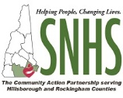
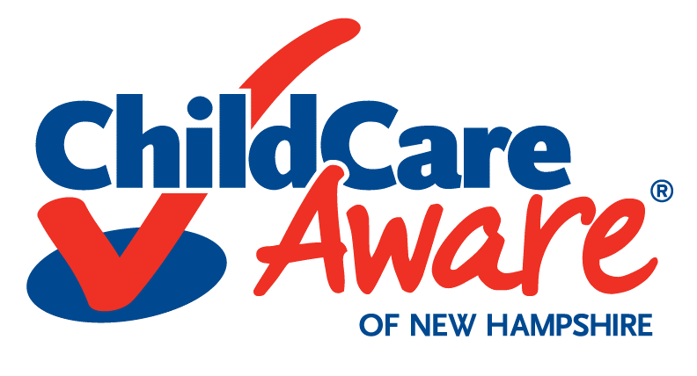
Progressive Training and TA Program
Open Enrollment Application Form

Child Care Aware of New Hampshire powered by Southern New Hampshire Services
Please email application to ccrrtraining@snhs.org.

Program Name: Click or tap here to enter text. Program License ID: Click or tap here to enter text.

Program Address: Click or tap here to enter text.
Contact Person and Role: Click or tap here to enter text.
Email: Click or tap here to enter text.
Phone: Click or tap here to enter text.
Program Capacity: Click or tap here to enter text. Total Number of Staff: Click or tap here to enter text.
Type of Program: Choose an item.

Please rate your interest in each of the Progressive Training and TA Program Options below:

Virtual Progressive Training and TA Program Options | High Interest | Moderate  Interest | No Interest
Environment Rating Scale (Starting in November 2020): Helps introduce programs to the different Environment Rating Scale (ERS) Tools, navigate the appropriate ERS tool, use the ERS to assess your program and use that assessment to enhance program quality. | ☐ | ☐ | ☐
Infant & Toddler Team Initiative: Helps a program's infant and toddler providers get their Infant/Toddler Endorsement, as well as works to incorporate the NH Early Learning Standards into their program. | ☐ | ☐ | ☐
NH Early Learning Standards: Helps programs incorporate the NH Early Learning Standards into the daily activities, planning and communication with families. | ☐ | ☐ | ☐
Program Emergency Preparedness and Response: Helps programs further develop their Emergency Operations Plan and Continuity of Operations Plan, as well as practice the Emergency Operation drills to help them be more equipped for an emergency. | ☐ | ☐ | ☐
Pyramid Model Intro and Overview: Helps administrators obtain Pyramid Model knowledge in order to build and sustain Pyramid Model practices within their program. | ☐ | ☐ | ☐
Strengthening Families, Strengthening Care: Helps programs evaluate their current practices around family engagement and make individual program goals to increase their work with the families they serve. | ☐ | ☐ | ☐

What Virtual Progressive Training and TA Program would you like to participate in? (Check one.)
☐ Infant & Toddler Team Initiative ☐ Program Emergency Preparedness and Response
☐ Pyramid Model Intro and Overview ☐ Strengthening Families, Strengthening Care
☐ NH Early Learning Standards ☐ Environment Rating Scale (Starting in November 2020)
Child Care Aware of NH, a Child Care Resource and Referral Program is powered by Southern New Hampshire Services. The preparation of this application was financed in part or in whole under a Contract with the University of New Hampshire in partnership with the State of NH, Department of Health and Human Services, Division of Economic and Housing Stability, Bureau of Child Development and Head Start Collaboration, with funds provided in part by the State of NH and the US Department of Health and Human Services. The application is supported by the Preschool Development Grant Birth through Five Initiative (PDG B-5), Grant Number 90TP0006, from the Office of Child Care, Administration for Children and Families, U.S. Department of Health and Human Services. The grant aims to understand the State’s early childhood system ​and to create a plan to improve outcomes for children, families, schools and communities throughout New Hampshire.

