**Child Care Workforce Assistance Project**

Frequently Asked Questions

Terms and Definitions:

1. Who is considered the “Applicant” on the application?
   1. For the purpose of the Child Care Workforce Assistance Project, an “Applicant” is defined as the individual completing Section 1 of the application (Employee). This person is the parent of the child AND the individual working in a child care program.
2. Who is considered the “Employer” on the application
   1. For the purpose of the Child Care Workforce Assistance Project, an “Employer” is defined as the individual completing Section 2 of the application. This person is the employer of the Applicant. *Who is considered the “Applicant” on this application?
3. Who is defined as a “Provider” on this application?
   1. For the purpose of the Child Care Workforce Assistance Project, a “Provider” is defined as the individual completing Section 3 of the application. This person is the Child Care Provider where the Applicant’s child is enrolled.

*If The Employer and the Provider are the same individual, then one email link will be sent to complete both sections of the application (Employer and Provider). Please be sure to monitor your email box frequently during the application process.

General FAQ:

1. Who do I email in regards to the Child Care Workforce Assistance Project?
   1. You can email Sarah Henry, Emma Salerni, and Heidi Hammell at [ccwap@pyramidmodel.org](mailto:ccwap@pyramidmodel.org)
2. Are there technical assistance opportunities for this application process?
   1. Yes! We are offering monthly office hours on the second Tuesday of each month during lunch time and individual appointments as needed.
   2. **Tuesday (Monthly) Office Hours:**

**Second Tuesday of the month January 14th - May 13th 12:30-1:30**

Topic: CCWAP Office Hours

Join Zoom Meeting

<https://us06web.zoom.us/j/87539256394?pwd=KUEVdgVJSbQb7CLQ7Pad8naIj0W8bH.1>

Meeting ID: 875 3925 6394

Passcode: 633300

* 1. To request individual office hours please email us at [ccwap@pyramidmodel.org](mailto:ccwap@pyramidmodel.org)

1. What are the prerequisites to apply for the Child Care Workforce Assistance Project?

* You are a NH resident
* You have applied for NH Child Care Scholarship within the last 3 months and were found not eligible based on your household income and household size
* You have reviewed the [*Child Care Scholarship Income Eligibility Chart*](https://nhfpi.org/resource/2024-child-care-scholarship-income-eligibility/)and believe that you currently earn between 85-100% of the state median based on your family size
* You have reviewed NH Connections webpage and available resources
* You have completed the Survey Monkey *Intent to Apply*
* You have verified that both your place of employment and your child’s child care program are eligible and enrolled in the NH Child Care Scholarship program.

1. How do I know what the Child Care Scholarship Income Eligibility is in 2025?
   1. Please view the updated chart as of 2024 [here](https://nhfpi.org/resource/2024-child-care-scholarship-income-eligibility/)
2. What documentation do I need to have prepared in order to complete the CCWAP Application?
   1. The only required documentation outside of the application itself is the Notice of Decision letter from New Hampshire Child Care Scholarship. In order to process your application we need the entire letter that you will receive from The State of NH once you are found ineligible for Child Care Scholarship.
   2. This is a 5-6 page document and can be uploaded directly into your CCWAP application on page 4 of the Employee section in DocuSign.
   3. Your application will be marked as “incomplete” until we receive the correct documentation.
3. Where do I apply for this project?
   1. Once you complete the Intent to apply survey using this [Survey Monkey Link](https://www.surveymonkey.com/r/2MJ866T), an email will be sent to you (the applicant), your employer, and your child care provider via DocuSign.
4. DocuSign is not letting me complete every section of the application, what do I do?
   1. This is because it is individualized for each signing party involved in the application. As the employee, you are only responsible for Section A. Once you have completed your section, the application will automatically be emailed to your employer and then to your child’s child care provider. Please note, if your child is enrolled in the same program where you work, then the employer and provider will be the same individual.
5. I have multiple children and am applying for CCWAP for each of them. Each of my children attends different programs, is this an issue?
   1. This is not a problem. Please report all provider information accurately when you complete the Intent to Apply Survey on SurveyMonkey (link found in Q. 9). We will then send a portion of the application to all parties involved in your child’s care.
6. When a staff member is awarded, will their child show up on DHHS state billing website?
   1. No, CCWAP is currently operated via a DHHS contract with Pyramid Model Consortium and all payments will be made monthly through a secure online financial platform, Bill.com. (See Q. 17 for more information regarding Bill.com).
   2. CCWAP staff will invoice directly on behalf of programs and the programs will receive a copy of these invoices each month until June 30, 2025.
7. I applied for Child Care Scholarship 6 months ago. Do I need to reapply for Child Care Scholarship first before I can apply for this project?
   1. Yes. Please reapply at [NH EASY](https://nheasy.nh.gov/#/apply-benefits) within 3 months of applying for this project. You will be notified of your enrollment status after application. Please keep any provided documentation if denied services; this is required upon application for the Child Care Workforce Assistance Project.
   2. You can utilize the [pre-screening too](https://nheasy.nh.gov/#/screening)l on NH EASY before you complete the Child Care Scholarship application if you desire. PLEASE NOTE: This is just a tool, you will still need to apply for Child Care Scholarship even if the screening tool says denied.
8. Why is the whole Child Care Scholarship Notice of Decision letter needed when applying for CCWAP?
9. The CCWAP award is based on an applicant applying for NH Child Care Scholarship and being found ineligible due to their gross household income (the income will need to be between 85% - 100% of the SMI). The applicant must otherwise meet all other eligibility requirements of NH Child Care Scholarship. The following information is referenced on the full Notice of Decision letter when determining eligibility for CCWAP:

* Date
* Scholarship eligibility decision and explanation (Denied or Open)
* Family Size (Image 1.2)
* Gross Monthly Income (Image 1.2)

1. The required information can be found in Image 1.1; An example of a Child Care Scholarship Decision Cover Page.

**Image 1.1**

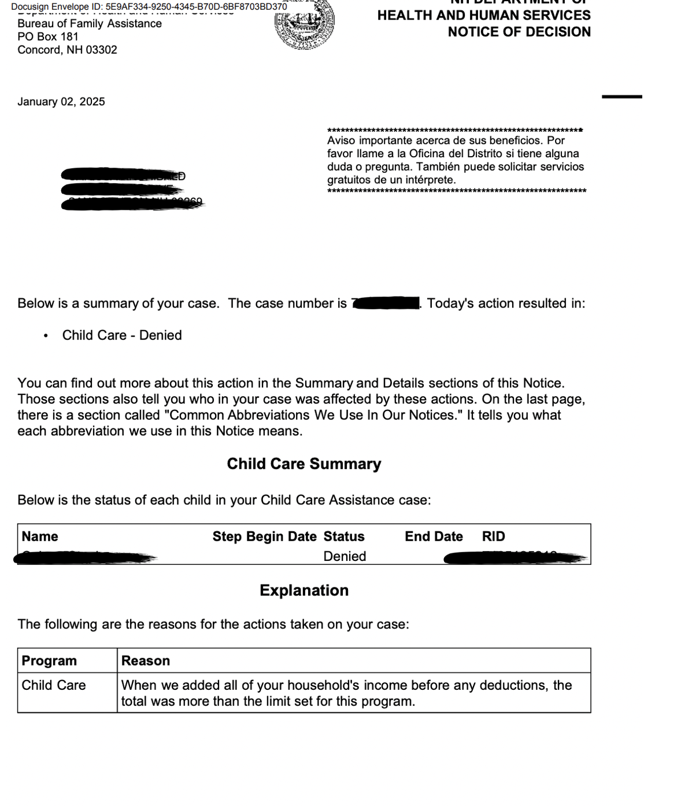

1. CCWAP requires a review of the gross monthly income for each family. Image 1.2 below is an example from a Notice of Decision Letter and required upon CCWAP application submission. It is titled, “Child Care Details” and lists verified financial information as shown.

**Image 1.2**

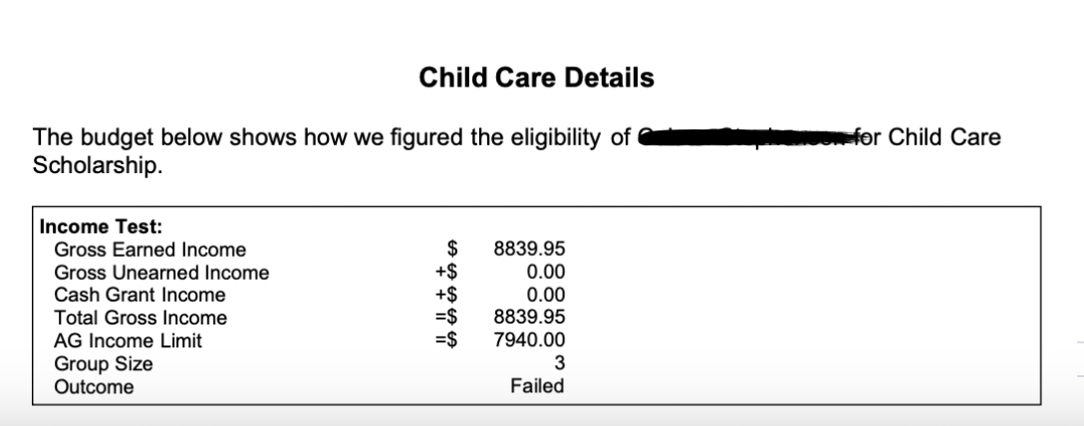

1. What types of programs can my child be enrolled in to qualify for CCWAP funding?
   1. This project’s funding can be used for care at licensed child care centers, licensed home child care centers, and licensed-exempt programs that are registered with the state and enrolled to accept the state’s existing child care scholarships.
2. My child attends the same child care that I am currently employed, is this okay?
   1. Yes! This does not void any qualifications for the project.
   2. Please make sure you accurately report this information when you complete your Intent to Apply Survey. You can use the same name and email for both the Employer and Provider.
3. How will payment be sent to the child care provider on behalf of the applicant?
   1. Providers will receive an email with instructions on how to receive monthly payments. Including a link from Bill.com to input financial information and an email from [finance@pyramidmodel.org](mailto:finance@pyramidmodel.org) with instructions to submit a W9.
   2. Bill.com link example:

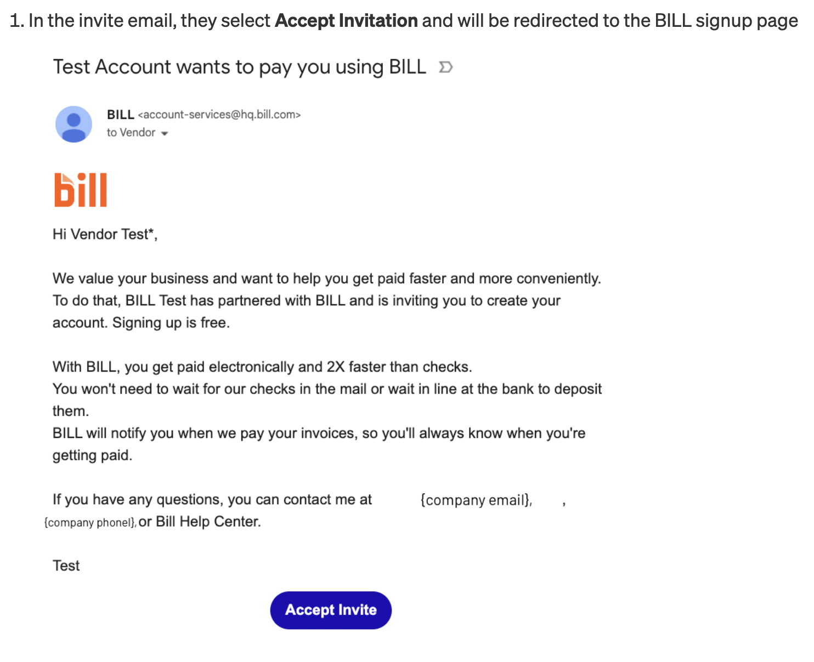

* 1. Once awarded, payments will follow a weekly schedule from January 1, 2025-June 30, 2025. Upon award, applicants will receive an Award Letter explaining when the payment will begin, the weekly payment amount, and the total payment amount over the 6 month period. You can view the chart below for reference (this also lives in the Award Letter).
  2. A provider has the opportunity to receive 25 weeks of payment if awarded from week 1. Payment will be dispersed over 6 monthly payments beginning in February 2025 and ending June 30, 2025 with the last payment coming in July 2025.
  3. Please note, until further notice, the total payment on the Award Letter will include four extra days of payment (January 1-3 and June 30, 2025). All applicants will receive the June 30th payment in their final award amount.

| **Week Number** | **Week Entering Project**  **(Date in award letter)** |
| --- | --- |
| Week 1 | January 1, 2025 |
| Week 2 | January 13, 2025 |
| Week 3 | January 20, 2025 |
| Week 4 | January 27, 2025 |
| Week 5 | February 3, 2025 |
| Week 6 | February 10, 2025 |
| Week 7 | February 17, 2025 |
| Week 8 | February 24, 2025 |
| Week 9 | March 3, 2025 |
| Week 10 | March 10, 2025 |
| Week 11 | March 17, 2025 |
| Week 12 | March 24, 2025 |
| Week 13 | March 31, 2025 |
| Week 14 | April 7, 2025 |
| Week 15 | April 14, 2025 |
| Week 16 | April 21, 2025 |
| Week 17 | April 28, 2025 |
| Week 18 | May 5, 2025 |
| Week 19 | May 12, 2025 |
| Week 20 | May 19, 2025 |
| Week 21 | May 26, 2025 |
| Week 22 | June 2, 2025 |
| Week 23 | June 9, 2025 |
| Week 24 | June 16, 2025 |
| Week 25 | June 23, 2025 - June 30, 2025 |

1. What is the purpose of CCWAP funding?
   1. The intent of this funding is to aid applicants with their child care payments. Payments should be directly applied to the applicant’s tuition bill regardless of any previous tuition discounts.
2. Is there an example of what a family might possibly have to pay for child care if awarded CCWAP funding?
   1. Yes, please see the following example based on a family of 4:

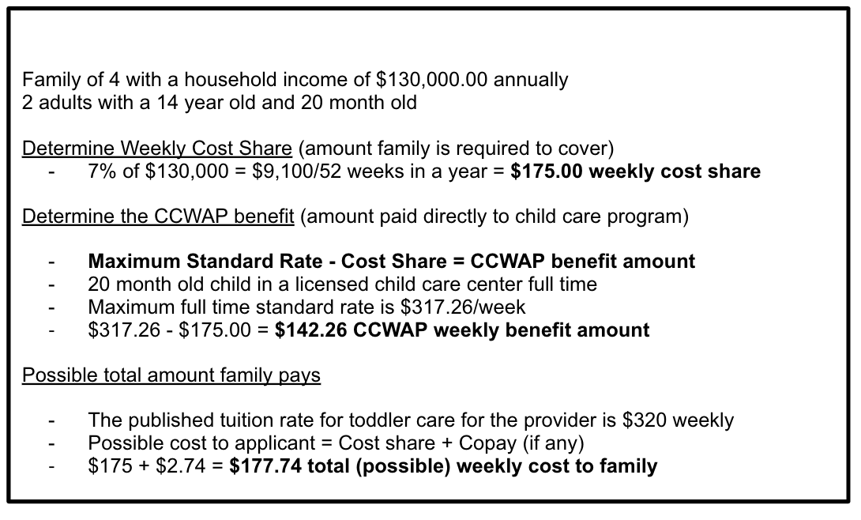

1. I was found eligible for CCWAP however my award amount is $0.00. How is this possible?
   1. As listed above, the CCWAP award is calculated based on your individual cost share amount (7% of your gross income) subtracted from the current [Market Rates](https://www.dhhs.nh.gov/sr_htm/html/sr_24-23_dated_08_24.htm). If your cost share is more than the Market Rate (based on your child’s age and attendance in the program), then your award amount could be equal to $0.00.
   2. We will work with staff who utilize more child care services during the project period such as during vacation weeks and holidays. It will be important to share that information with us in advance.
2. I applied and received a “Notice of Incomplete Application,” email now what?
   1. If your application was incomplete, you have 15 days from the date you receive your notification of the missing documentation letter to return the required documentation to the review team. If you do not send the missing documentation in time, you will be required to submit a new application and your award date would follow the new application/award date.
3. I do not agree with the determination of my application for the Child Care Workforce Assistance Project; What do I do?
   1. You have the right to formally appeal any decision made within 15 days of receipt. Please email us at [ccwap@pyramidmodel.org](mailto:ccwap@pyramidmodel.org) in order to begin the appeal process.
4. I am a home provider, can I apply for CCWAP for my own child?
   1. You can not apply for Child Care Scholarship or CCWAP if you are caring for your own child in your home.
   2. You can apply for benefits if your child attends a program outside your home (e.g., your school age child attends an after school program).